Review for Structure of the Heart Quiz
1. What is the size of the heart, and where is it located?

2. What are the two firbous layers of the heart, and where are they located?

3. What are the three layers of the heart muscle?

4. What is the purpose of the pericardial cavity?

5. What are the two types of circulation?

6. Name the four chambers of the heart.

7. What structure separates the left side from the right side of the heart?

8. Label the four valves found in the heart.
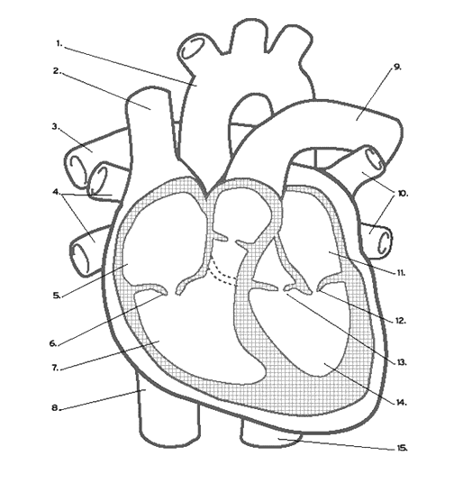

9. Describe the path of bloodflow throughout the body.

10. ***Notice the pulmonary VEINS are the only veins to carry OXYGENATED BLOOD to the heart (from the lungs). Notice the pulmonary ARTERIES are the only arteries to carry DEOXYGENATED BLOOD from the heart to the lungs.***

11. What are the three main types of blood vessels?

12. What are the layers of the blood vessels?

13. Why does the tunica intima have a smooth surface?

14. Why is the tunica media layer so thick in arteries?

15. What is the only layer present in capillaries? Why?

