Nervous System Review

- What are neurons?
- What is a synapse?
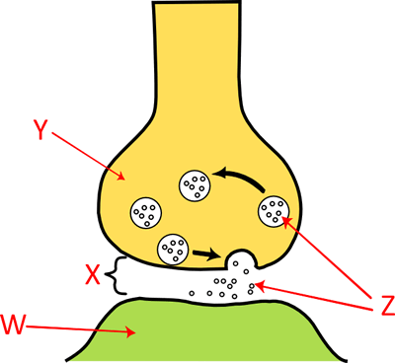
- How does communication between neurons occur?
- What are the three basic functions of the nervous system?
- What are the two functions of the nervous system, and what is included in each?
- What are the four types of neuroglial cells found in the CNS, and what is their function?
- How can the PNS be divided? What is the function of each?
- Compare and contrast the somatic and autonomic nervous systems.
- What are the two types of neuroglial cells found in the PNS, and what is their function?
- What is the difference between white and gray matter?
- Identify what structural neuron is present in each.
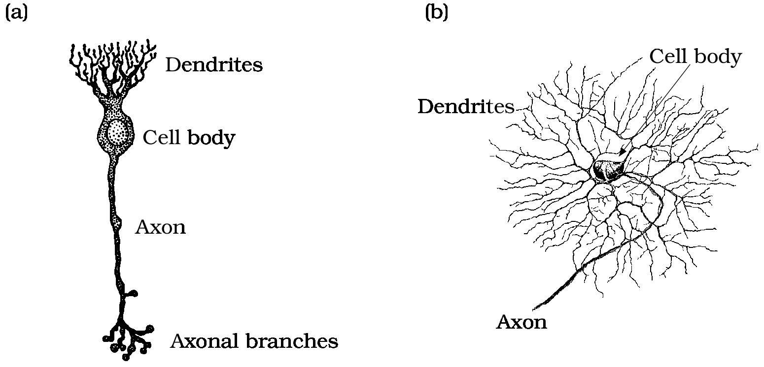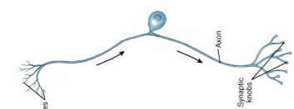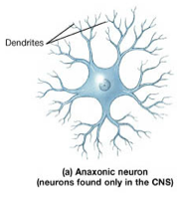

- What are the three functional classifications of neurons?
- What is an action potential?
- What is a threshold?
- What is the “all or none” principle?

- Label and explain the following on the action potential graph below: hyperpolarization, depolarization, repolarization, and resting potential.

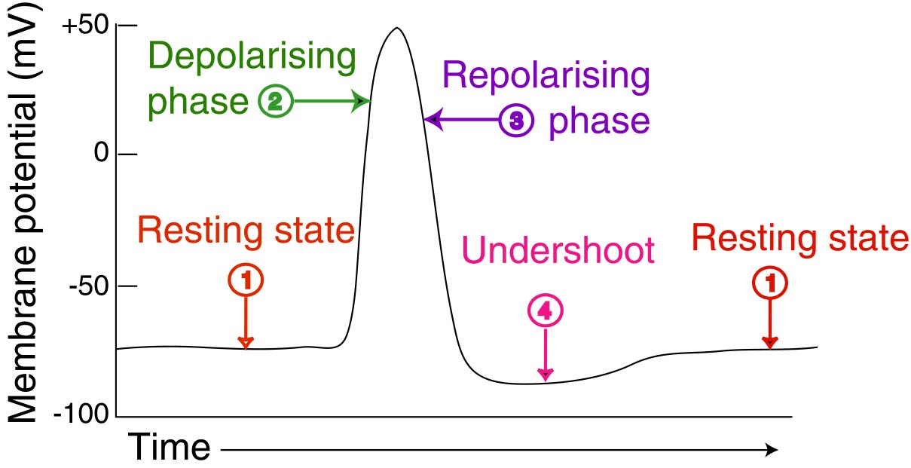
- Put the following steps of an action potential in order.
_____ Potassium rushes out of cell to balance out differences in membrane potential
_____ Action Potential reaches axon terminal and calcium channels open
_____ Neurotransmitters bind to receptors on dendrites
_____ Vesicles with neurotransmitters inside travel to end of axon terminal
_____ Neuron is at resting potential (-70 mV)
_____ Membrane potential becomes more positive ( +30mV)
_____ Membrane potential goes to -100 mV but then goes back to -70 mV
_____ Vesicles release neurotransmitters into synaptic cleft
_____ Causes sodium to rush into cell body
_____ Continues along the length of the axon
_____ Calcium enters axon terminal and binds to vesicles
_____ Sodium channels close
_____ Neurotransmitters travel through synaptic cleft and bind to next neuron

- What is a mixed nerve?
- What are the three layers that make up the meninges in the nervous system?
- What is a spinal tap and when would it be done?
- What is a spinal block, and when would it be used?

- Label the layers that surround individual nerve fibers.
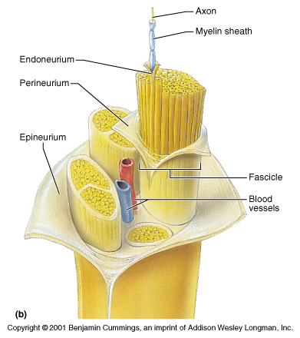
- What is a reflex? Where do most reflexes occur?
- What are the four layers of protection of the brain, from outside in?
- What is the function of the CSF?
- What are the three major parts of the brain, and what is their function?
- What structures are included in the brainstem, and what is their function?
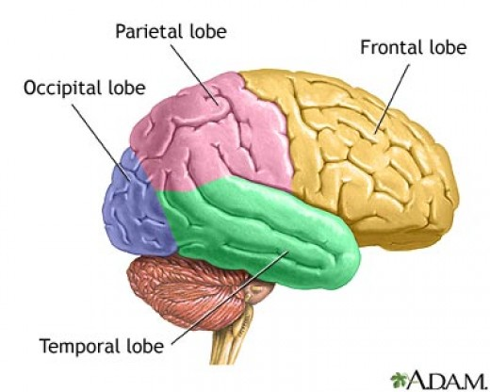

- What is the function of each lobe?
- What is the function of the pituitary gland?
- What is the function of the hippocampus?
- What is the limbic system, and what is included in it?

