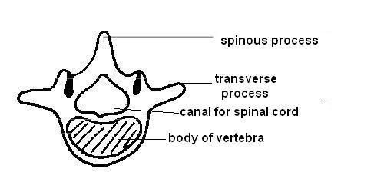
Axial Skeleton – Vertebral Column and Rib Cage Guided Notes
1. Contains ____ bones:
  - Vertebrae (_____)
  - Sacrum
  - Coccyx (_________________)
Functions:
- ______________ head, neck & trunk
- protect ________________ _______________
- maintain ________________ body position
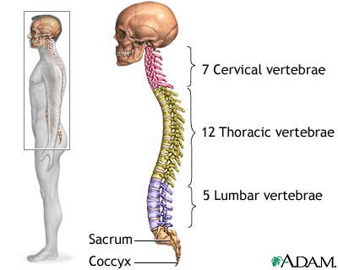

2. The vertebral column consists of three main parts: _______________________ (C1-C7), _____________________ (T1-T12), and ________________________ (L1-L5) vertebrae.
3. The first cervical (C1) vertebrae is called the _______________. The second cervical (C2) vertebrae is called the _____________. REMEMBER: the atlas spins around its axis!

4. Cervical vertebrae are _____________, have smaller bodies, and a _____________________ (divides into two branches) spinous process. Thoracic vertebrae have _____________________ bodies and a spinous process that projects ________________________. Lumbar vertebrae have the _________________ bodies and the __________________, ______________________ spinous process of all the vertebrae.
5. The thoracic vertebrae function to ____________________ heart and lungs. It consists of the ___________, ______________________, and ________________________________.
6. Aka _____________ (_____ pairs). The 1st 7 pairs are called ____________ ribs. Pairs 8-12 are called ______________ ribs because they do not attach _________________to the sternum. The last two pairs (11 and 12) are called __________________ ribs, and they do not touch the sternum. The cartilage between the ribs and sternum is called the __________________ cartilage.
7. A _____________________ is a projection at one end of a bone for the attachment of a muscle or tendon
8. The _______________ bone attaches tongue, voice-box, and throat. It is the only bone in the body not directly ______________________ (articulated) with another bone. When broken, it can be an indication of __________________________ as cause of death. In children, the greater horns have not ____________ to the body yet, so fractures may not always been seen even if strangulation occurs. Fusion of the hyoid rarely occurs before the age of ________.

